**Student as Researcher Camp**

**A one-week curriculum designed to get students involved in field research**

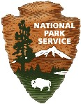

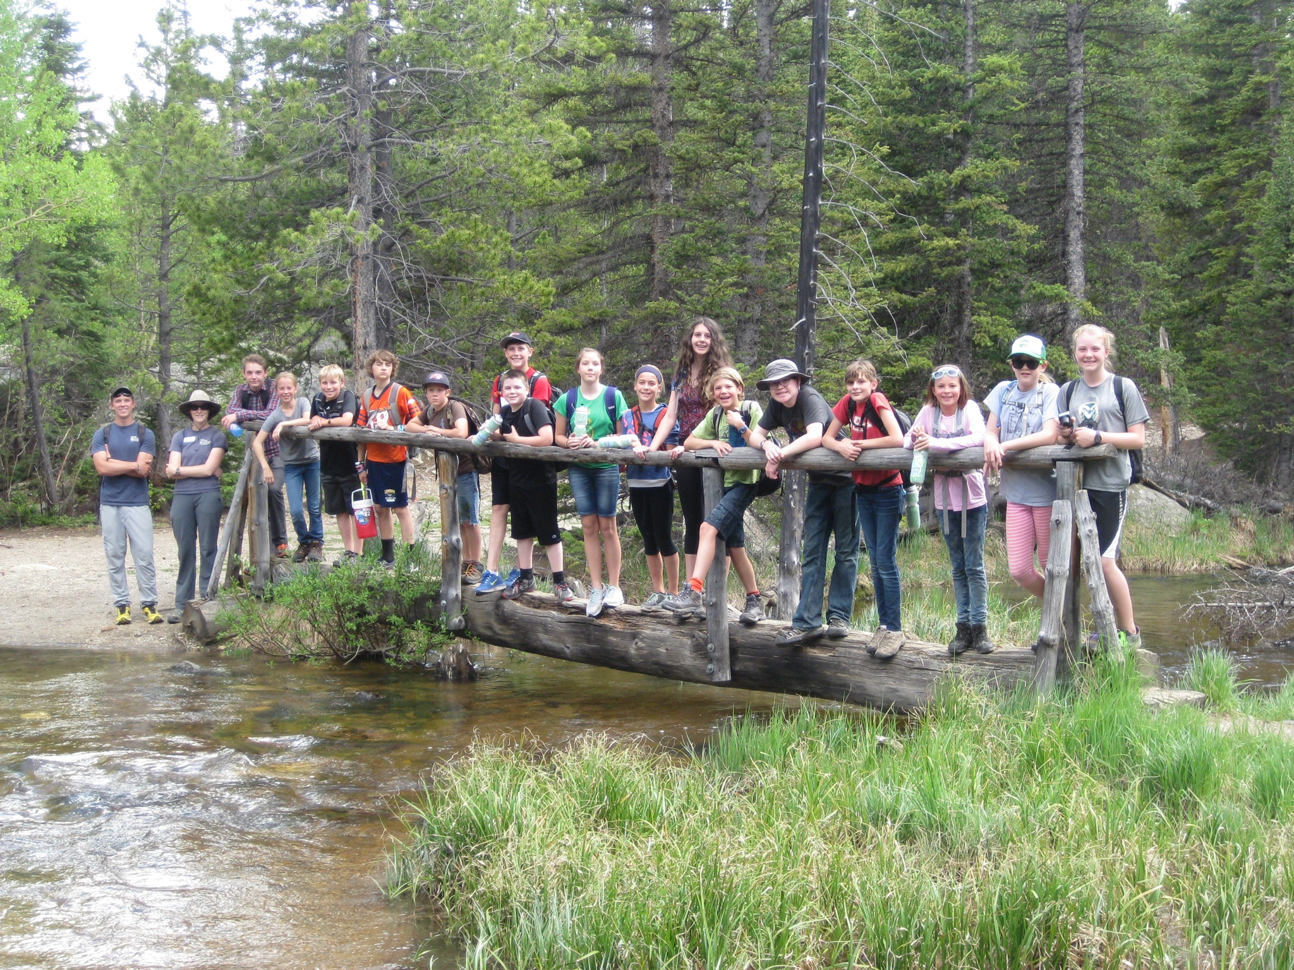***Middle School Curriculum***

**Mary Klass, Geological Society of America, Geocorps America Program; Retired Poudre School District, Fort Collins, CO, Science Teacher**

**Sally Plumb, National Park Service, Natural Resources Stewardship and Science**

**July 1, 2015**



**Student as Researcher Camp**

**Middle School Curriculum**

**I. Introduction**

**II. Camp Outline**

**A. Day 1 Topic: Getting to Know Each Other and Basic Research Skills**

**Focus Question: What do you wonder about in the natural world around you?**

**Magic Words: “I wonder…”**

**Morning Activities:**

**Introduction:** Welcome to Science Researcher Camp--The instructor will cover areas of importance that the students should know in order to have a successful camp.

**Get To Know You Game:** Students will participate in different get-to-know you games to facilitate interactions and friendships within the group. (Toss the Ball)

**Setting up Field Notebooks:** The instructor will have students put name on the front with a permanent marker, explain and create a table of contents, notebooks will be organized by day of the week with its activities, last five pages are kept for list of animals or plants seen during the week.

**Break / Morning Treat**

**How to Identify Mammals:** The information given by the instructor focuses on the identifying characteristics of four common major mammal orders: ungulates, carnivores, rodents, and lagomorphs.

**Mapping Activity - Part 1:** This mapping activity starts to give students an idea of distance and an awareness of different features that are important in their surroundings.

**Afternoon Activities:**

**Film Canister Rockets:** Students will learn about variables and how to control them by changing the amount of effervescing antacid tablets and water to get the rocket to stay aloft the longest time.

**Get to Know You Game:** Students will participate in different get-to-know you games to facilitate interactions and friendships within the group. (Have you ever…)

**Break / Afternoon Treat**

**Research Projects—Brainstorm Ideas:** Students start to think about what they want to do for a research project—suggest major areas of study and show different equipment options: include animals, plants, macroinvertebrates, insects, invasive species, wildflowers, rocks, soil, weather, human/nature interactions

**Learning Walk / Journaling:** Take a short nature walk identifying any animals you see and some major plants for the week list. If time, the students will sit and journal about a given quote and draw one plant or animal.

**B. Day 2 Topic: Picking a Science Research Topic**

**Focus Question: What things are important when conducting scientific research?**

**Magic Words: “What if …”**

**Morning Activities:**

**Team Building Challenge:** Teambuilding challenges are designed to present a problem that can only be solved by working together as a team and not an individual. Part of the challenge is to solve the problem, but a larger part of the challenge is to work with team members in a positive and productive way.

**Mapping Activity - Part 2:** The second part of the mapping activity involves the students going back to the original site (identified in Mapping Activity—Part 1) to find the pictures of different plants and animals placed by the instructor beforehand and plot the location of each on the map that the students drew and colored on the first day.

**Break / Morning Treat**

**How to Identify Insects:** The information given by the instructor focuses on the identifying characteristics of eight major insect orders: Coleoptera, Hymenoptera, Odonata, Hemiptera, Lepidoptera, Homoptera, Orthoptera, and Diptera

**Picking a Topic and Partner:** The instructor will list the major topics on a board or paper, then go around the group and write names of students interested in a topic and maybe a particular area within the topic. After all student names are listed, the instructor will have students get into the groups by topic and see if they can find someone with a similar idea for a project.

**Afternoon Activities:**

**Guest Research Speaker:** Students will be given the chance to interact with a scientist and hear about his/her current or ongoing research related to the environment or different organisms.

**Identify Research Question / Project Planning:** The instructor will give students a chance to discuss possible research question and present to instructor for further processing. If time, the instructor will allow students to start to collect data.

**Break / Afternoon Treat**

**Learning Walk / Journaling:** The students will take a short nature walk identifying any animals they see and major plants for the week list. If time, the students will sit and journal about a quote and draw one plant or animal.

**Overnight Debrief:** The instructor will go over needed information for the next two days and the overnight trip.

**C. Day 3 Topic: Overnight Field Trip to __________________**

**Focus Question: How is this location different from our previous study site?**

**Magic Words: “Look at…”**

**Morning Activities:**

**Field Trip to Second Field Site:** The instructor should take time to make sure students have all the necessary supplies for the overnight field trip.

**Travel time**: Travel time will vary depending on the location of the second field site.

**Introduction to Second Field Site:** Upon arrival at the second field site, the instructor should talk about any new or different rules students need to understand that are unique to the site and have a safety briefing.

**Unpack and Settle In:** Students should be given time to unpack, set up their sleeping area, and get acquainted with the new site.

**Afternoon Activities:**

**Practice Data Collection as a Group:** The instructor will talk about data collection in the field and do an example as a whole group.

**Learning Hike:** The instructor will plan a hike that includes several stops to look at things students can learn from the site.

**Collect Data for Personal Research:** Students should be given the opportunity to collect data for their project.

**Evening Activities:**

**Eat Dinner / Free Time:** As a group, the instructor and students will meet before dinner / free time to go over eating procedures and to establish meeting times and any necessary rules.

**Campfire Activities:** The instructor will give different campfire challenges (including maybe starting the fire). Later in the evening, the group will make S’mores and enjoy the evening outdoors.

**D. Day 4 Topic: Finish Up Research and Head Back to First Site**

**Focus Question: How are the two different sites alike or different in your data collection?**

**Magic Words: “I think…”**

**Morning Activities:**

**Sunrise Wildlife Walk:** Getting up early is not something middle school students like to do, but making them get up early and experience sunrise in the woods, in the mountains at the beach, beside the lake (or wherever the class might be) is almost always a gratifying experience for all.

**Guest Research Speaker:** Students will be given the chance to interact with a scientist and hear about his/her current or ongoing research related to the environment or different organisms.

**Collect Data for Student Projects:** Students should be given the opportunity to collect data for their projects.

**Pack Up and Head Back:** Students need to be given time to pack up, clean their rooms/campsite, and have lunch before heading back to the original field site.

**Afternoon Activities:**

**Trip Back to Original Field Site:** Travel time will vary depending upon the choice of the two different sites for the student’s research.

**Unpack / Debrief:** Students should help unpack team equipment and help clean up and organize for the rest of the camp.

**Learning Walk / Journaling:** The students will take a short nature walk identifying any animals they see and some major plants for the week list. If time, the students will sit and journal about a quote and draw one plant or animal.

**E. Day 5 Topic: Analyze Data and Presentations**

**Focus Question: “What can we learn from the data we collected from the two sites?”**

**Magic Words: “I found out…”**

**Morning Activities:**

**Collect Data for Personal Research:** Students should be given the opportunity to collect data for their project from the original site.

**Team Building Challenge:** Teambuilding challenges are designed to present a problem that can only be solved by working together as a team and not individually. Part of the challenge is to solve the problem, but a larger part of the challenge is to work with your team members in a positive and productive way.

**Break / Morning Treat**

**Graphing and Data Analysis Information:** Review appropriate display of data and how to use the correct graph to display information.

**Make Data Tables and Graphs for Poster:** The instructor should provide the students with appropriate paper to make data tables and graph for their poster presentation.

**Afternoon Activities:**

**Learning Walk / Journaling:** The students will take a short nature walk identifying any animals they see and some major plants for the week list. If time, the students will sit and journal about a quote and draw one plant or animal.

**Prepare Poster Presentations:** Students prepare posters showing the research they conducted during the week between the two different field locations

**Break / Afternoon Treat**

**Poster Presentation for Parents and Guests:** The students will invite parents and guests to come and view the students’ research.



**Introduction**

Summer camps are an exciting way to keep students learning year round and not just during the traditional school year. There are many options for students to pick from for summer activities and this camp takes advantage of being outdoors in the summer and learning about nature / science at the same time. “Students as Researchers” Camp gives students the opportunity to conduct their own scientific research over the course of a week at two different outdoor research sites.

At its core, this camp provides the chance for students to make choices—by exposure to different topics they will pick a research topic, decide on research partners, determine how to conduct their research, and problem-solve different choices in team building challenges. The article “Choices for Children—Why and How to Let Students Decide” describes several benefits for giving students choices: “(1) Effects on general well-being—it is desirable for people to experience a sense of control over their lives, (2) Effects on behavior and values—if we want children to take responsibility for their own behavior, we must first give them responsibility, (3) Effects on academic achievement—deprive students of self-determination will likely deprive them of motivation, (4) Effects on teachers—the job becomes a good deal more interesting when it involves collaborating with students to decide what is going to happen, and (5) Intrinsic Value—allowing people to make decisions about what happens to them is inherently preferable to controlling them.” (Kohn, 1993)

It is important to provide time for students to learn about each other and bond together as a large group and as smaller research groups. Each non-traveling day includes a “Get to Know You” or “Team Building” time to promote bonding within the group and to challenge students to make choices and to alter their choices to solve a problem. Within the document are suggestions for different activities, but if an instructor wishes to look for other ideas, there are many books and websites available with alternate activities. The instructor should choose an activity that applies to the needs of the group.

Each day includes a focus question to share with students to help them understand the purpose of the day. Also, included are “Magic Words”. Depending on the instructor’s comfort level, it is fun to play with the students. Every time a student says the “Magic Words” everyone makes a happy sound or the group can keep track of number of times the words are used for a treat at the end of the day. “Magic Words” is also a way to keep student attention focused on the focus question of the day.

**Next Generation Science Standards**

This camp meets many standards found in the Next Generation Science Standards. It not only meets Life Science but also Nature of Science standards.

**MS-LS2: Ecosystems: Interactions, Energy, and Dynamics—**Analyze and interpret data to provide evidence for the effects of resource availability on organisms and populations of organisms in an ecosystem. (MS-LS2-1)

**MS-LS2: Ecosystems: Interactions, Energy, and Dynamics—**Construct an explanation that predicts patterns of interactions among organisms across multiple ecosystems. (MS-LS2-2)

**MS-LS2: Ecosystems: Interactions, Energy, and Dynamics**—Science disciplines share common rules of obtaining and evaluating empirical evidence. (MS-LS2-4)

**MS-LS2: Ecosystems: Interactions, Energy, and Dynamics**—Organisms, and populations of organisms, are dependent on their environmental interactions both with other living things and with nonliving factors (MS-LS2-1)

**MS-LS2: Ecosystems: Interactions, Energy, and Dynamics**—Patterns can be used to identify cause and effect relationships (MS-LS2-2)

**MS-LS3: Ecosystems: Interactions, Energy, and Dynamics--**Science assumes that objects and events in natural systems occur in consistent patterns that are understandable through measurement and observation (MS-LS2-3)

**Acknowledgements**

Thanks to John Howe, STEM Coordinator of the Summer STEM Institutes, Poudre School District, Fort Collins, Colorado and Kristen Dean, Program Coordinator for the Colorado State University (CSU) Environmental Learning Center (ELC) for testing out this curriculum during the Summer STEM Institutes.

**Introduction Resources**

Kohn, Alfie. "Choices for Children: Why and How to Let Students Decide (*) - Alfie Kohn." *Alfie Kohn*. Phi Delta Kappan, 02 Sept. 1993. Web. 20 June 2015. <http://www.alfiekohn.org/article/choices-children/>.

Lead States, NGSS. "The Next Generation Science Standards | Next Generation Science Standards." *Next Generation Science Standards: For States, By States*. N.p., 2013. Web. 22 June 2015. <http://www.nextgenscience.org/next-generation-science-standards>.